11.2 Acids and bases
Name: ____________________ Class: ____________________ Due date: 11.30
1. Two indicators, bromophenol blue and Congo red, show the following colours in acidic solutions and in alkaline solutions.
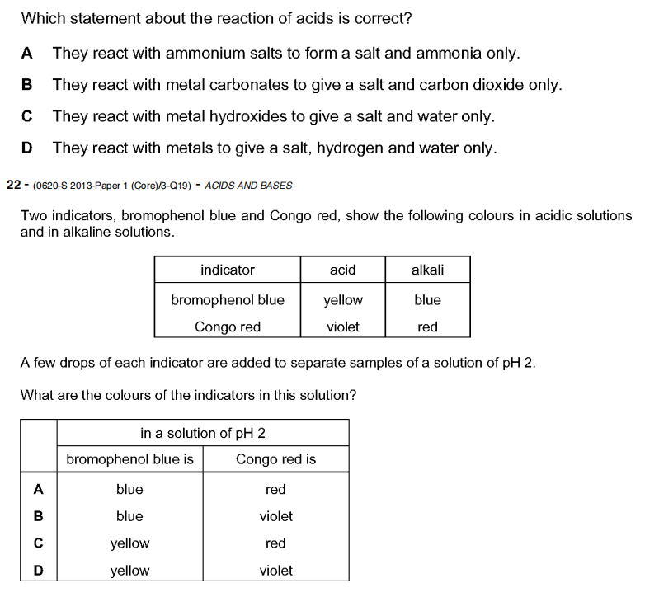
A few drops of each indicator are added to separate samples of a solution of pH 2.
What are the colours of the indicators in this solution? （ ）
2. The table shows the pH of four aqueous solutions, W, X, Y and Z.
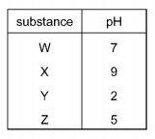
Universal Indicator is added to each solution.
Which row shows the colour of each solution after the indicator is added? （ ）
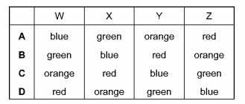

$0.1 {\text{mol/dm}}^{3}$$0.1 {\text{mol/dm}}^{3}$$0.1 {\text{mol/dm}}^{3}$$0.1 {\text{mol/dm}}^{3}$3. Which solution has the lowest pH? （ ）
A ammonia solution
B ethanoic acid
C lithium hydroxide
D nitric acid

4. Potassium hydroxide is a base.
Which statement describes a reaction of potassium hydroxide? （ ）
A Chlorine is formed when it is heated with ammonium chloride.
B It turns Universal Indicator green.
C It reacts with an acid to produce a salt and water.
D It turns methyl orange red.
5. Which row shows the difference between a weak acid and a strong acid? （ ）
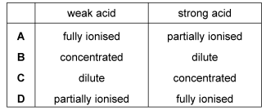
6. Which statement describes the properties of hydrochloric acid? （ ）
A Carbon dioxide is produced when limestone reacts with hydrochloric acid.
B Hydrogen is produced when sodium hydroxide reacts with hydrochloric acid.
C Methyl orange turns yellow in strong hydrochloric acid.
D Red litmus paper turns blue when dipped into hydrochloric acid.

7. What is a characteristic of acids? （ ）
A Acids turn methyl orange indicator yellow.
B Acids have a high pH value.
C Acids react with ammonium salts to give ammonia gas.
D Acids react with carbonates to produce salts.

8. Which of the following solution shows the lowest acidity? （ ）
A. HCl solution with ph of 2
B. CH₃COOH solution with ph of 3
C. Na₂CO₃ solution with ph of 8
D. NaOH solution with ph of 14

9. Which substance is the most alkaline? （ ）
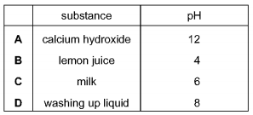

10. Which of the following solution shows the lowest acidity? （ ）
A. HCl solution with ph of 2
B. CH₃COOH solution with ph of 3
C. Na₂CO₃ solution with ph of 8
D. NaOH solution with ph of 14

11. A gas is escaping from a pipe in a chemical plant.
A chemist tests this gas and finds that it is alkaline.
What is this gas? （ ）
A ammonia B chlorine C hydrogen D sulfur dioxide
12. Dilute hydrochloric acid is added to a solid, S.
A flammable gas, G, is formed. Gas G is less dense than air.
What are S and G? （ ）
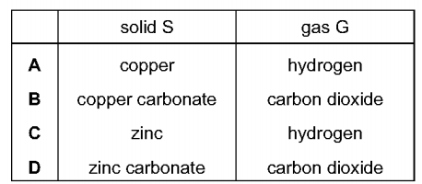

13. The diagram shows two substances, X and Y, being heated together.
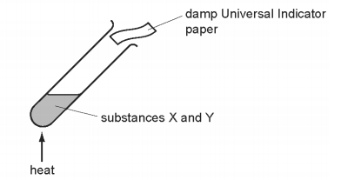
The Universal Indicator paper turns blue during the experiment.
What are substances X and Y? （ ）
A ammonium nitrate and hydrochloric acid
B ammonium nitrate and sodium hydroxide
C sodium carbonate and hydrochloric acid
D sodium carbonate and sodium hydroxide

14. Which statement about the reaction of acids is correct? （ ）
A They react with ammonium salts to form a salt and ammonia only.
B They react with metal carbonates to give a salt and carbon dioxide only.
C They react with metal hydroxides to give a salt and water only.
D They react with metals to give a salt, hydrogen and water only.

15. Which are properties of an acid? （ ）
1 reacts with ammonium sulfate to form ammonia
2 turns red litmus blue
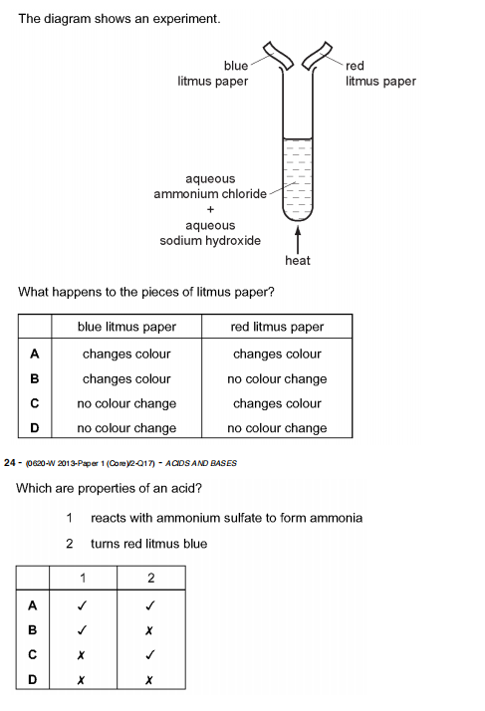

16. Which statements about alkalis are correct? （ ）
1 When reacted with an acid, the pH of the alkali increases.
2 When tested with litmus, the litmus turns blue.
3 When warmed with an ammonium salt, ammonia gas is given off.
A 1, 2 and 3 B 1 and 2 only C 1 and 3 only D 2 and 3 only

17. The diagram shows an experiment.
What happens to the pieces of litmus paper? （ ）

18. Which method can be used to obtain ammonia from ammonium sulfate? （ ）
A Heat it with an acid.
B Heat it with an alkali.
C Heat it with an oxidising agent.
D Heat it with a reducing agent.

19. Which statement is not correct? （ ）
A When a base reacts with an ammonium salt, ammonia is given off.
B When an acid reacts with a base, neutralisation takes place.
C When an acid reacts with a carbonate, carbon dioxide is given off.
D When the acidity of a solution increases, the pH increases.

20. Which reaction is not characteristic of an acid? （ ）
A It dissolves magnesium oxide.
B It produces ammonia from ammonium compounds.
C It produces carbon dioxide from a carbonate.
D It produces hydrogen from zinc metal.

21. Which property is not characteristic of a base? （ ）
A It reacts with a carbonate to form carbon dioxide.
B It reacts with an acid to form a salt.
C It reacts with an ammonium salt to form ammonia.
D It turns universal indicator paper blue.

22. Which statement is not correct? （ ）
A When a base reacts with an ammonium salt, ammonia is given off.
B When an acid reacts with a base, neutralisation takes place.
C When an acid reacts with a carbonate, carbon dioxide is given off.
D When the acidity of a solution increases, the pH increases.

